Local Area Assessment
5 Manor Park Road London E12 5AB

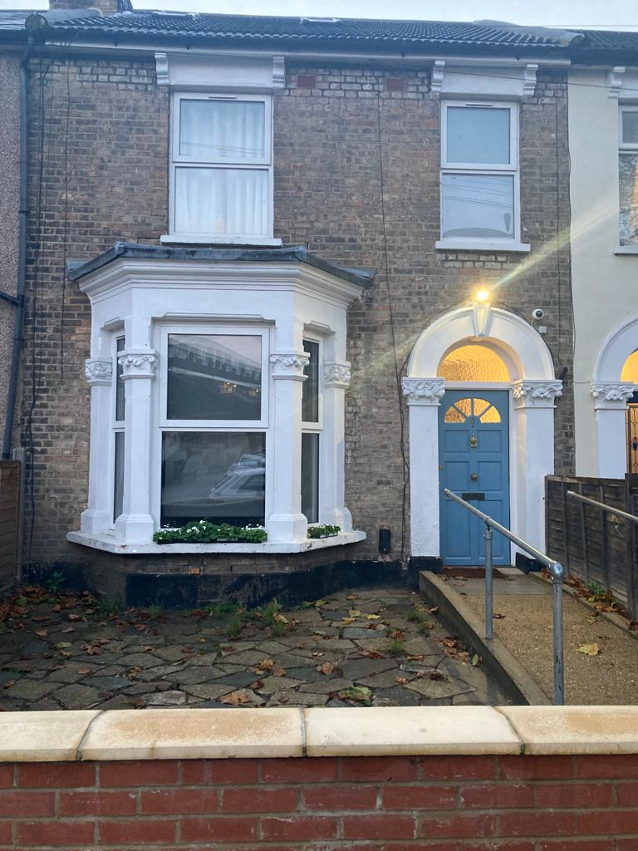

Nurture with Nature Care Service is a Victorian terraced residential home situated within the London Borough Newham

The London borough of Newham

Newham is one of the 33 boroughs that make up Greater London, it is located in East London just north of the river Thames adjacent to Greenwich, Hackney and Tower Hamlets. It is a very densely populated borough with an above average population of under 25's.
The different districts of Newham are:
- Beckton - An up and coming area that is still affordable and in close proximity to Canary Wharf and The City in Central London.
- Canning Town - An area that is currently undergoing a £3.7 billion regeneration which involves building 10,000 new homes and two new town centres so is defintely a place to watch!
- Custom House - A dockland area that was once infamous as a slum sitauted next to Beckton and Canning Town. Like it's neighbours it too is also going through significant regeneration.
- Cyprus AKA New Beckton this is area is situated on the eastern end of the Royal Albert Dock and is an area popular with students from the nearby University of East London.
- East Ham - An area with great transport links to District and Hammersmith and City underground lines. It is a reasonably priced area which is comprised of large Victorian and Edwardian properties.
- Forest Gate - Another area that has great transport links for getting into Central London via Liverpool Street, and boasts some great curry houses.
- Little Ilford - A mainly residential area close to Manor Park and Aldersbrook.
- Manor Park - A mainly residential area comprising of Victorian terraced homes that has great transport links for getting into central London. It is an east London area which has a high amount of green space.
- Maryland - Situated in close proximity to the Queen Elizabeth Olympic Park and the Westfield shopping centre. A currently up and coming area.
- Mill Meads - Home to a nature reserve, it is now primarily a commercial area.
- North Woolwich -
- Plaistow - A rare reasonably affordable area in London that is mostly a residential area. It is said to lack in good pubs and clubs but is situated very close to Central London areas such as Canary Wharf.
- Plashet - Situated adjacent to West Ham it offers great transport links to central London. A mainly residential area.
- Silvertown - Once a former industrial area it is currently undergoing extensive re-development where 3,000 new homes will be built. An area that is set to become very desirable due to its location on the River Thames.
- Stratford - Stratford has undergone big changes since being the host London's 2012 olympics which has brought new housing, shops and restaurants.
- Stratford City - Stratford has undergone big changes since being the host London's 2012 olympics which has brought new housing, shops and restaurants.
- Stratford Marsh - Stratford has undergone big changes since being the host London's 2012 olympics which has brought new housing, shops and restaurants.
- Stratford New Town - Stratford has undergone big changes since being the host London's 2012 olympics which has brought new housing, shops and restaurants.
- Temple Mills - Situated next to Lee Valley Park Temple Mills has great transport links.
- Upton - The home of West Ham United Foot ball Club it has a vibrant Asian community with great restaurants and a food and clothes market on Queens Road.
- Upton Park - The home of West Ham United Foot ball Club it has a vibrant Asian community with great restaurants and a food and clothes market on Queens Road.
- Wallend - A residential area in close proximity to East Ham tube stop.
- West Ham - Has some really great transport links with good nightlife and attractions.

Facts about Newham

- Hosted the 2012 summer Olympics at Olympic Park
- The second fastest growing London borough
- 10% of the borough is green space

Transport In Newham

This is an area currently undergoing redevelopment so expect to see many more stations appearing with the completion of the Jubilee Line Extension and the introduction of Crossrail.
Underground, Dlr and Overground Stations
- Abbey Road
- Beckton DLR
- Beckton Park DLR
- Cyprus DLR
- Canning Town Station
- Custom House
- East Ham
- Forest Gate
- Gallions Reach
- King George V
- London City Airport
- Manor Park
- Maryland
- Plaistow
- Pontoon Dock
- Prince Regent
- Royal Albert
- Royal Victoria
- Star Lane
- Stratford Station
- Stratford High Street
- Stratford International
- Pudding Mill Lane
- Upton Park
- Wanstead Park
- West Ham
- West Silvertown
- Woodgrange Park Railway

Property Prices:
Property prices are much lower than the London average and is a great place to buy if a first-time buyer. A detached house can cost as little as £557k which although a lot of money is considerably lower than the average price of a London detached home at £1.1m.

The absence of a safe and secure place in which to live can have an extremely negative impact on physical and emotional health and wellbeing. This report displays data on overall crime and a breakdown of crime types for Newham.
Single crime case data have been aggregated for Newham and rates are calculated per 1,000 population. 12-month rolling figures use an average of the population monthly figures over the same period. Where the dates for the crime data exceed the latest available date for population estimates, the latest population figure was used for any crime rates after that date (no extrapolating)
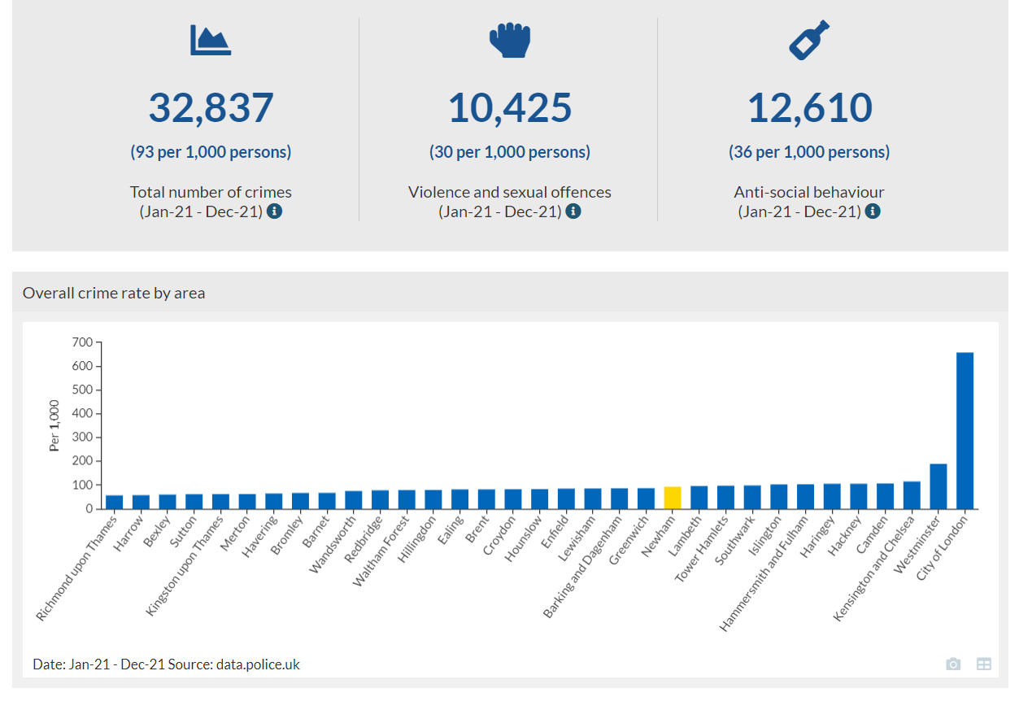
Date: Jan-21 - Dec-21 Source: data.police.uk

5 Manor Park Road London E12 5AB
